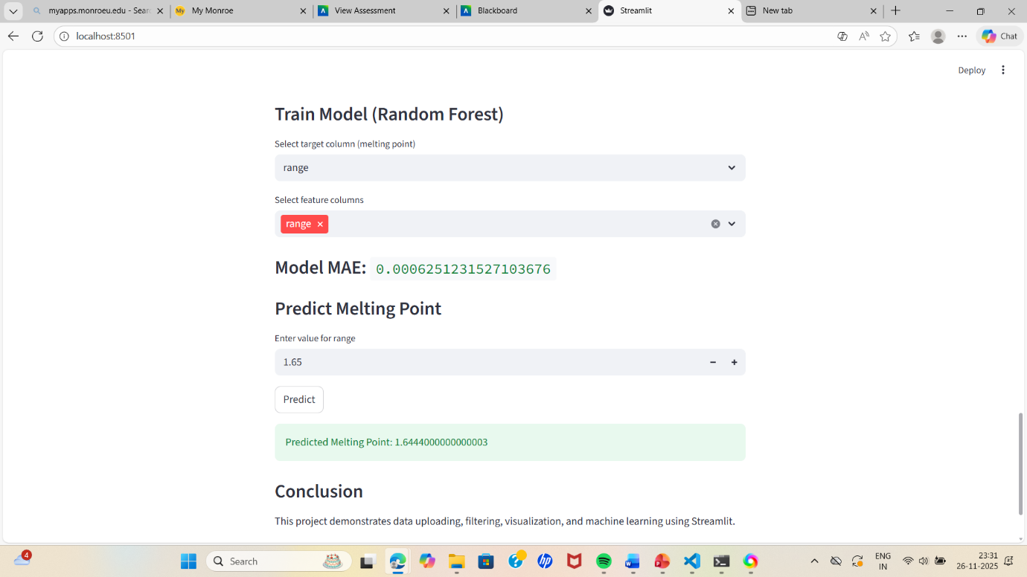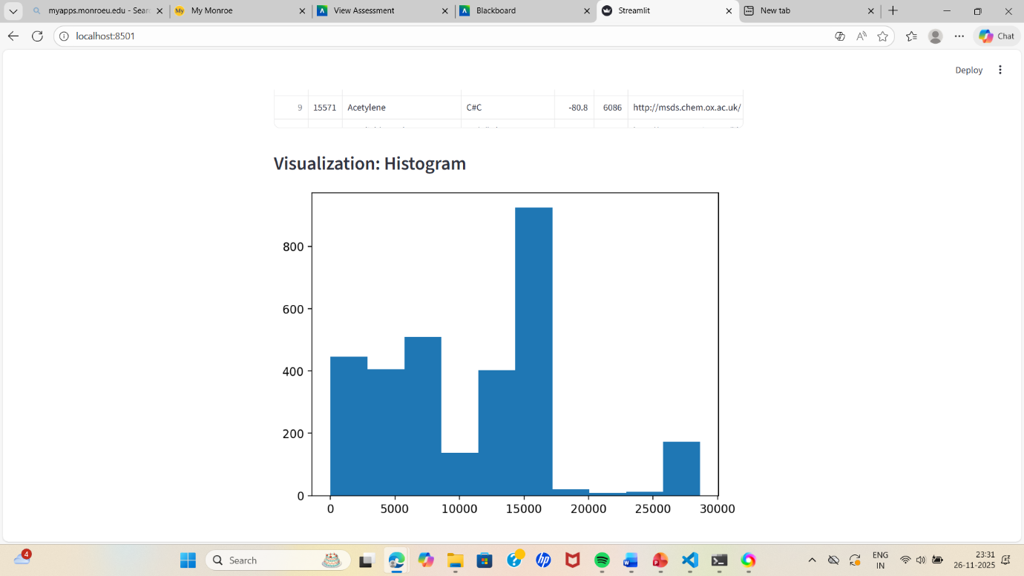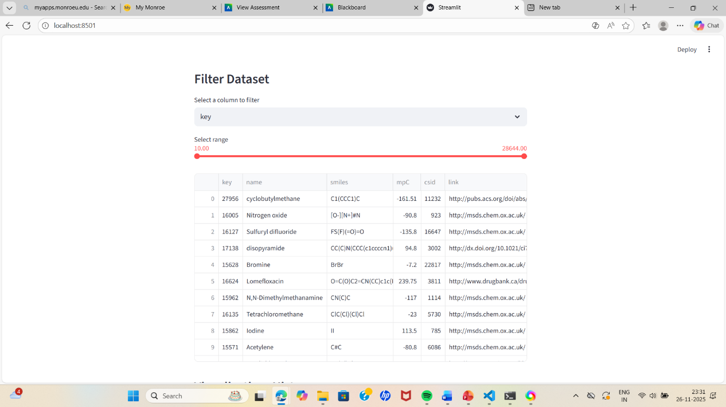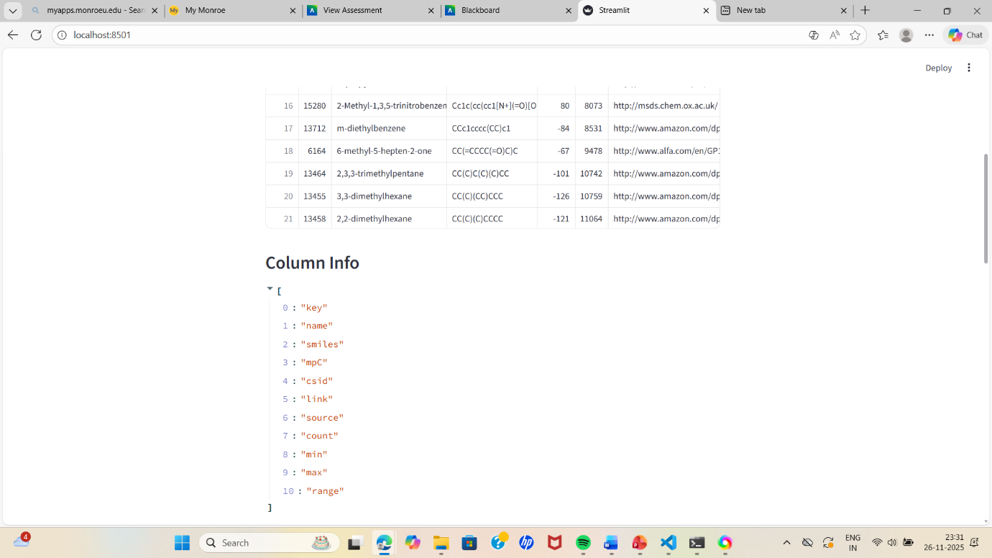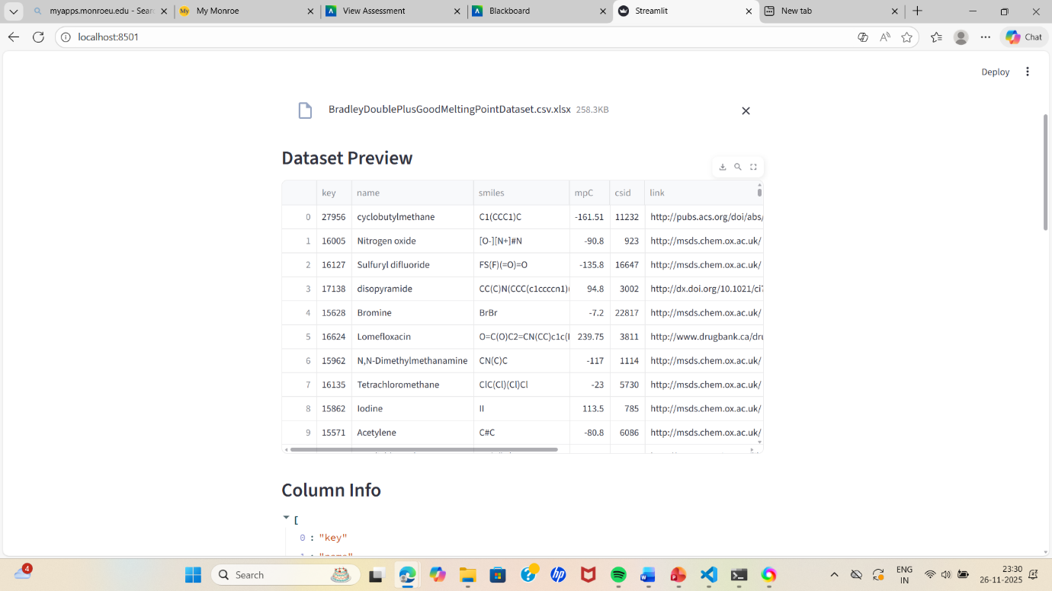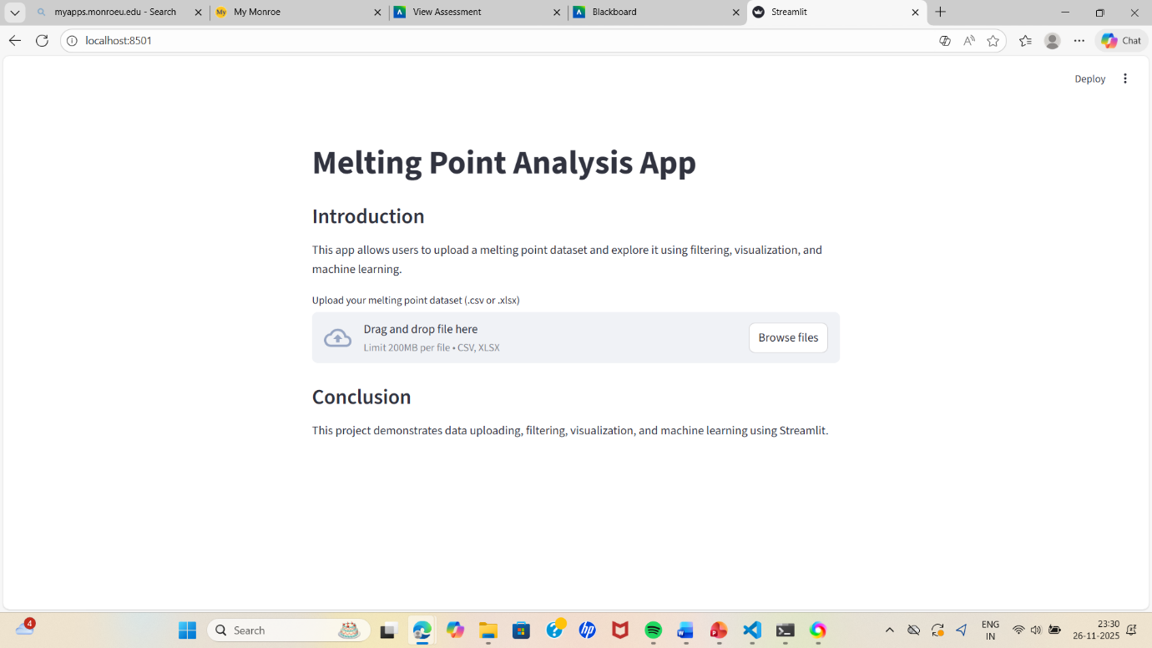

ASSIGNMENT-2
GAYATHRI SAMA
MONROE UNIVERSITY, KING GRADUATE SCHOOL
25FL-CS620-152HY – SOFTWARE SYSTEM DESIGN
SYED FARID
09-28-2025

INTRODUCTION:
WHAT IS AGILE PROCESS?
Agile process is like a flexible one, and tasks can be split into parts with constant feedback.
WHAT IS THE WATER-FALL PROCESS?
The waterfall process is a very structured, step-by-step process; everything is planned.
I believe the agile process will work better for our project this semester.
Regarding the project this semester, I believe the agile process is much better than the waterfall process. The main reason is that in the agile process, work can be divided into parts and shared among team members, who can frequently receive feedback if any changes are needed. On the other hand, the waterfall process is a step-by-step approach that involves design, coding, testing, and then moving on to the next step. That's why, in the class project, which requires frequent changes, the workload can be shared among team members instead of falling on one person.
For example, in my last semester, I did a project where we divided our work into parts: gathering data, creating an SQL, data entry, writing queries, and finally presenting all the information in a PPT. This way, we divided the work and made changes together, completing our project using an agile process. That’s why I believe the agile process is good for class projects because it helps me in this way. In this process, it can change frequently until the project is done. Team members can share work and work consistently without waiting for a time to end. All group participation is there here.
While doing group projects, the main problems are miscommunication, uneven workload, not everyone responding at the same time, and the inability to finish on time. However, in the agile process, work is shared very evenly, small mistakes can be corrected, and tasks are completed within the deadline. This process ultimately results in an even and proper output without any misunderstandings, it also encourages good communication, and finally achieves the project's success.
CONCLUSION:
Agile process is the best one in my opinion, with this process, work can be shared, flexible, and good communication between the team members is very important in team projects in class. While the waterfall process is for predicted work, and difficult to make changes for our project, it requires frequent changes if required, communication between the team members is important, and can avoid regular problems coming in between the teamwork. That’s why I will choose the agile process for the class project this semester.

